Using Jenkins

Download & Install Jenkins

After finish installation run Jenkins on web browser at <http://localhost:8080/> I was using Chrome as my web browser

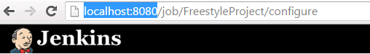

I used several plugin

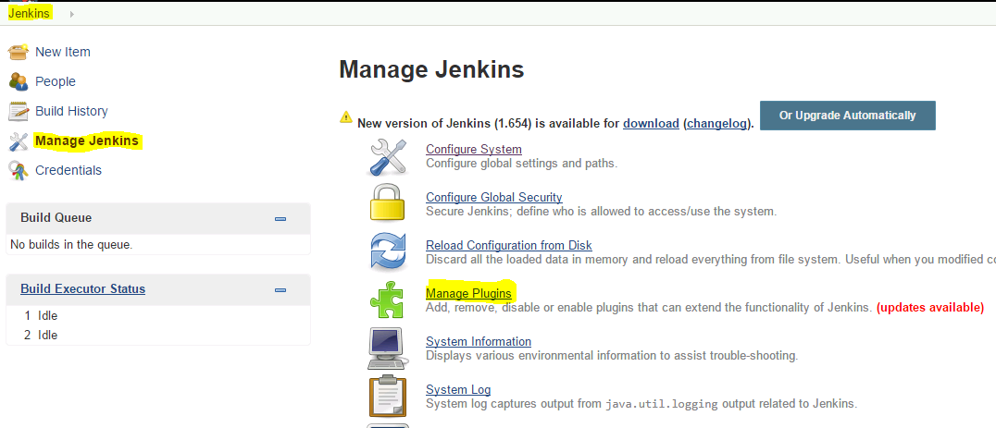

The plugins I installed

1. [Subversion Plug-in](http://wiki.jenkins-ci.org/display/JENKINS/Subversion+Plugin)
2. [xUnit plugin](http://wiki.jenkins-ci.org/display/JENKINS/xUnit+Plugin)
3. [Maven Integration plugin](http://wiki.jenkins-ci.org/display/JENKINS/Maven+Project+Plugin)

Configuring a simple FreeStyle Project to load from SVN

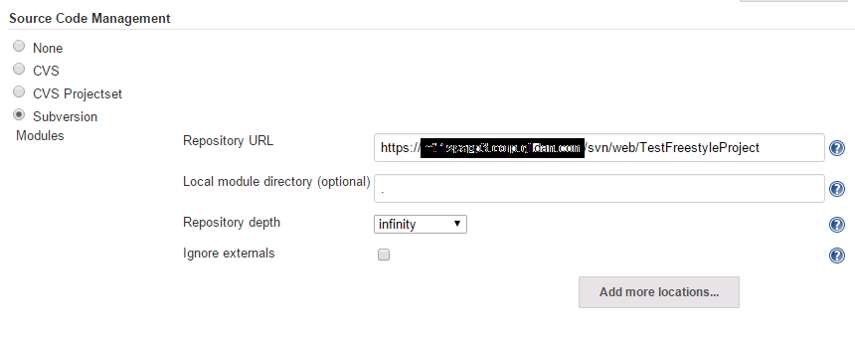

Setup build triggers

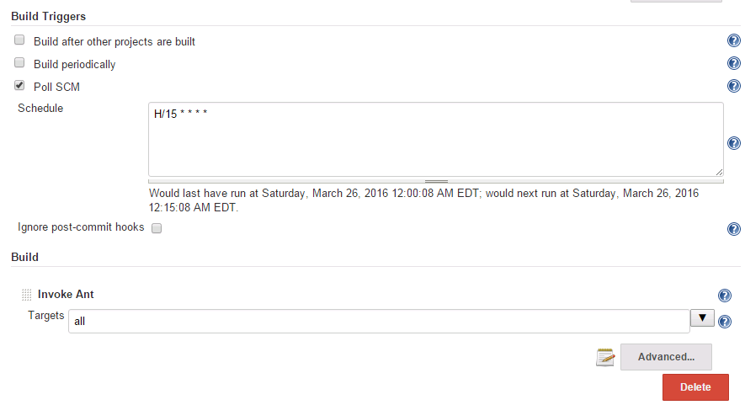

Using Ant Build as an example to setup Build in Jenkins

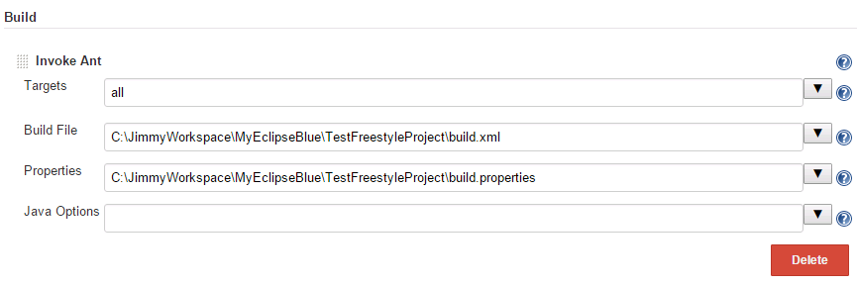

After

